A Day in the Life of a Holy Cross Girl
Holy Cross is a good school for girls. Our teacher is Ms.Lagan, she is a good teacher. We go to assembly on Monday mornings. Usually we do maths first. Next we go outside for our break. After we do phonics.
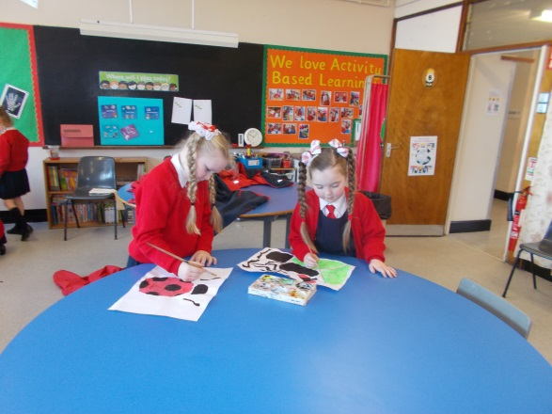
On Friday we do Golden Time. We play on the ipads. On Wednesday we do P.E. At 12 o’clock we go for our lunch. After we go outside. We go on the bus when we go to school.
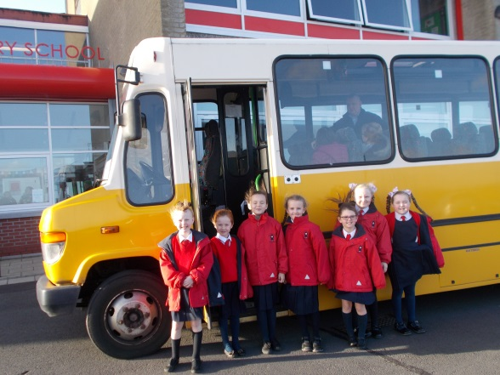
We do art. On Friday we do our spelling. My name is Kelsey. Our school is the best.
By Kelsey McConnell P4

