A Day in the Life of a Holy Cross Girl
Our school is called Holy Cross Girls’ Primary School. We have 170 pupils. We have 8 classrooms. Our principal is called Mrs. McNally. Our teachers are very nice, some are strict.
In the mornings we have breakfast club. We have break at 10.30am. We go out for break. Our pitch is red. I think our school is safe. We have Golden Time. Golden Time is where you play with toys. In our school the girls are very nice. We learn numeracy and in the morning we do morning activities. We have a job list. We have a cloak room so we hang our coats and bags there.
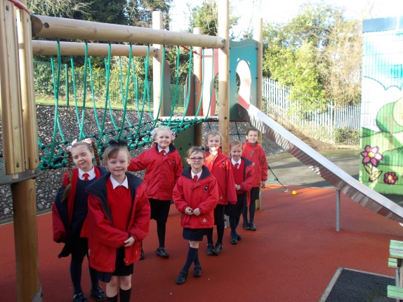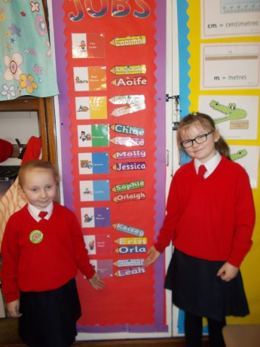
We do art, our topic is about World War Two. We do P.E. on Wednesdays, our coach is called Seamus. We have reading strategies
We have a literacy task board. Our lunch is at 12 o’clock. We have a climbing frame. On Tuesdays we go to singing in the afternoons. We have reading time too. Our classroom is full of things to help you if you are stuck. I feel our school is very safe.

