A Day in the Life of a Holy Cross Girl
Our school is called Holy Cross Girls’. I get a bus to school, we go to assembly. At break time we play with the toys. We do literacy at eleven o’clock. We do numeracy for homework.
In our school we have 170 girls. We go to lunch at 12 o’clock. We play chasies. On a Thursday we go into the playroom. Our classroom has a big board.
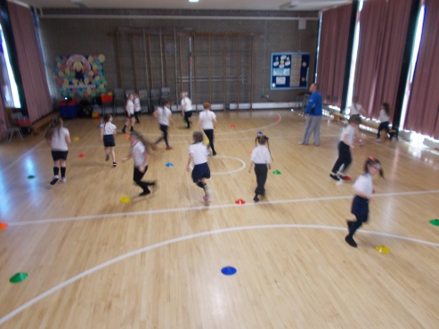
I like going on trips. We do PE at 1 o’clock, my coach is called Seamus. When I am bored I play with my friend Molly.
I really like doing hard work. Our classroom has a clock. My table is called the Rainbows. Sometimes we do art on Thursdays. We go on the climbing frame. Sometimes we go into the computing suite. We have a sandpit, it has toys with it. 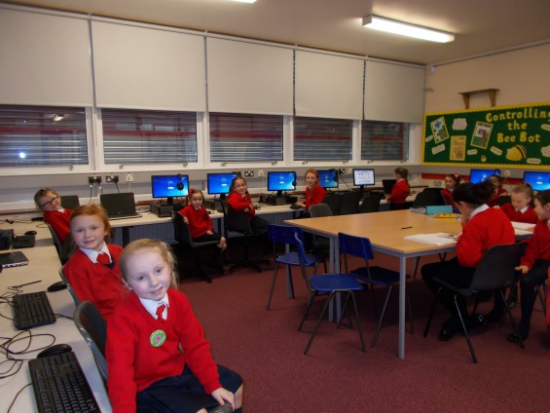
We are learning about World War Two. The school has got ipads. We do art in the playroom, there are lots of pictures of us. We have a toyshop in the playroom.
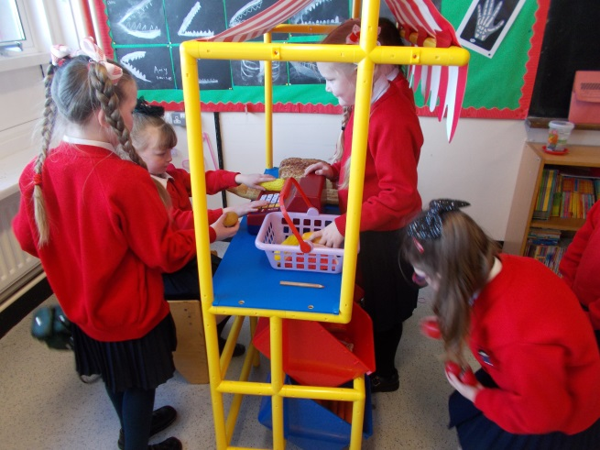
We have Read in Bed every year and Mrs McElroy reads to us. Every year we dress up as characters.
Out in the playground we have balls. My teacher is called Ms Lagan. Our classroom assistant is called Mrs Cheung. For art I made a crocodile.
By Katie Ellen Murphy P4

