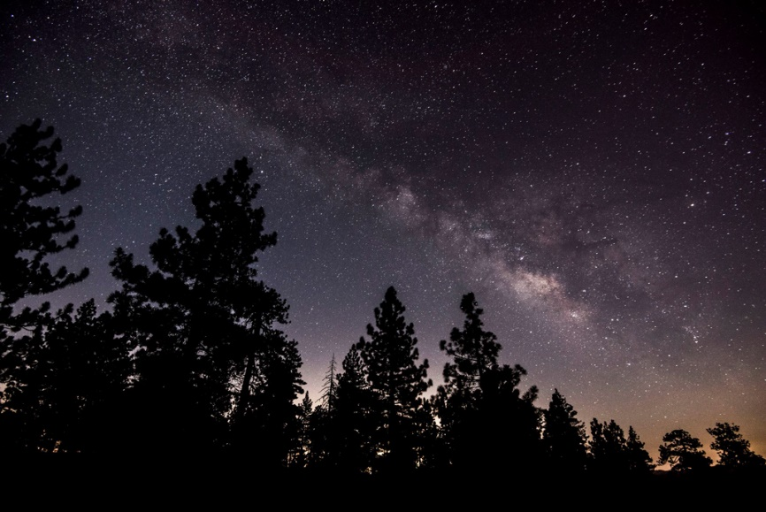
Does God Know?
The glistening stars caught my eye.
That one star sparkling, is that a sign?
Sometimes when I look up to the heavens.
I forget that I’m Eily.

Sky oh sky! You make me drift.
I feel brave when I see you!
The beauty of you reminds me of Mother.
This makes me feel free and like no other.

Let’s do this, take a deep breath.
I’m sure mother won’t even react.
Oh mother, does He even know?
What have we done to deserve this.
Please give us luck. Please oh please.
We’re suffering too hard.
Oh, just give us hope!

Mother, oh mother
She cannot guarantee
That we are going to be fine!
The shawl keeps me snuggled,
warm and free.
Oh God, let us feel free.
Can this be a dream…

By Safia McKernan

