Does God Know?

As I stand outside looking up at a beautiful sky all around me
I think about all our suffering.
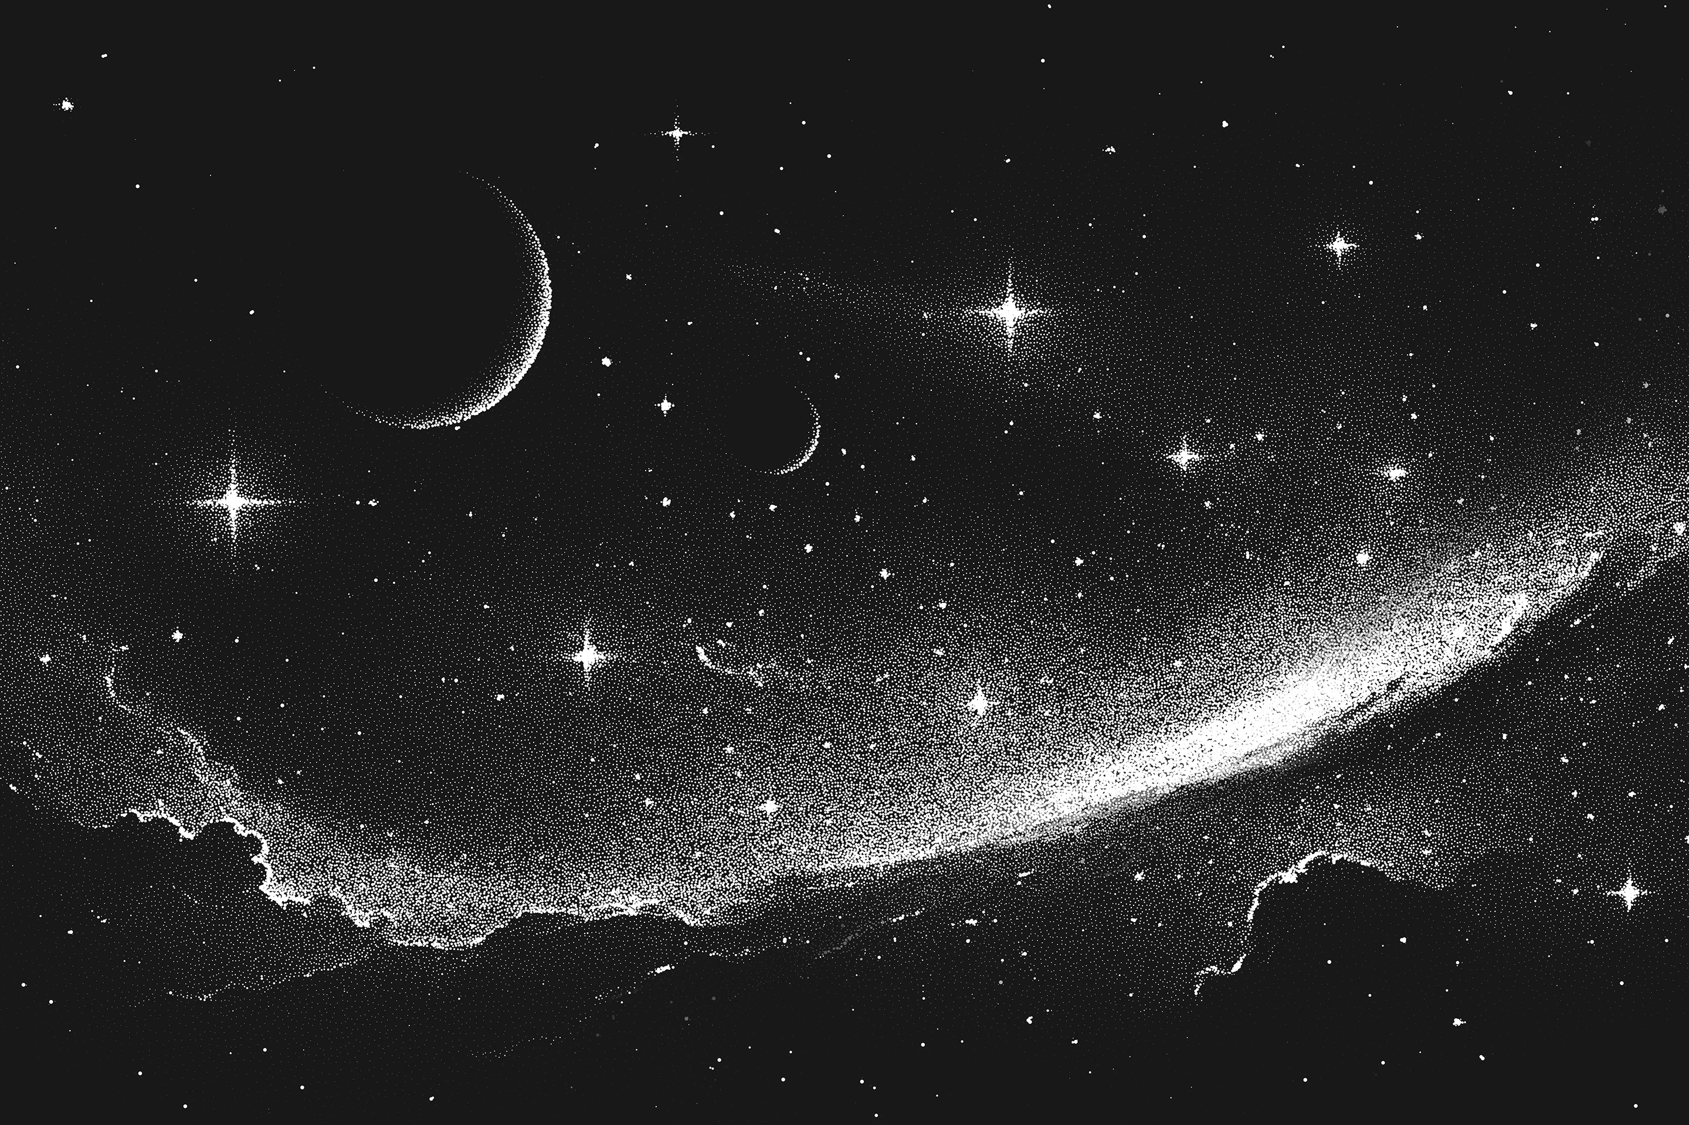
I’m just a little girl from a little island and
God’s world is vast and giant!

Does He even know what’s going on in our country?

It took great courage to ask my mother this.
I was worried that it would come off as disrespectful.
Would she be upset with me?
It took great courage to ask this, go without saying it.
I could no longer keep this question inside!

I question myself, if He hasn’t forgotten about us then
Why are the people of Ireland starving?

I shut my eyes and hoped, really hoped, it wouldn't make my mother upset!
But then she took off her shawl, wrapped it around my shoulders
Lovingly and gave me a big hug!

I know child! I wonder too, but the important thing is that you and I,
Peggy and Michael, stay together and take care of each other.

By Rhía Martin

