Sometimes I Wonder…

Just then I followed mother out of the
Cottage to find a mesmerising view of the
Glistening sky.

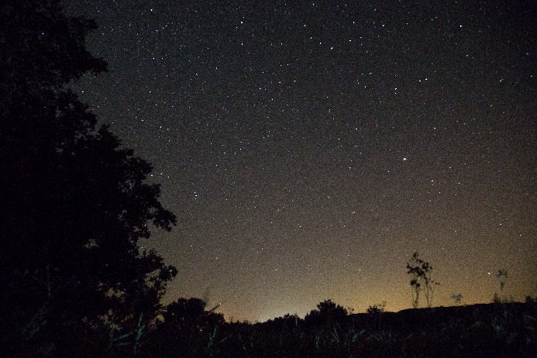
Then it hit me, the question
That I have felt doubtful
To ask, but it’s a spectacular
Dark void above in the distance.
So, if there is a right thing to do, I’ll go
By my gut!

As I gathered the courage to ask the question
I have been wondering for quite a while now.
I asked mother, “Sometimes I wonder does
God even know what is happening down here?”
The reply I got was, “I know pet I wonder too!
God acts in such strange ways.”

Oh! Then mother wrapped me up
In her shawl. In that moment
I felt very close to my mother and that
Memory will live with me forever!

By Reeva O’Neill

