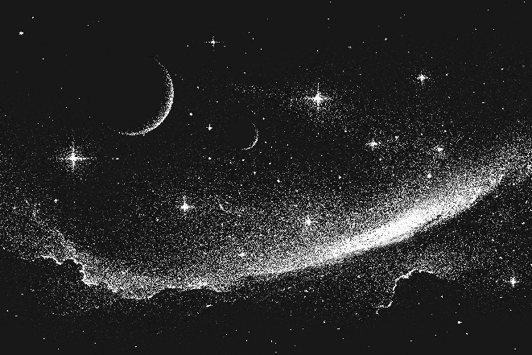
The Moment in Time

The celestial sky upon my eye
It was lustrous, the darkness of the sky.
With all the stars stuck inside, the tingles
Of last night, the beauty, the elegance had opened up
Had the shivering all night long

The beauty distracted me from my worries and thoughts
Was it time I opened up?
The sky seems normal but the hunger
Had been plying on my mind all night.

Sometimes I wonder does God even know?
Does he even care?
At times I wonder does he watch me lie in despair.

I am wrapped in her love
In the snug shawl
I’m so glad mother’s with me now and for all.

By Katie Lowe

