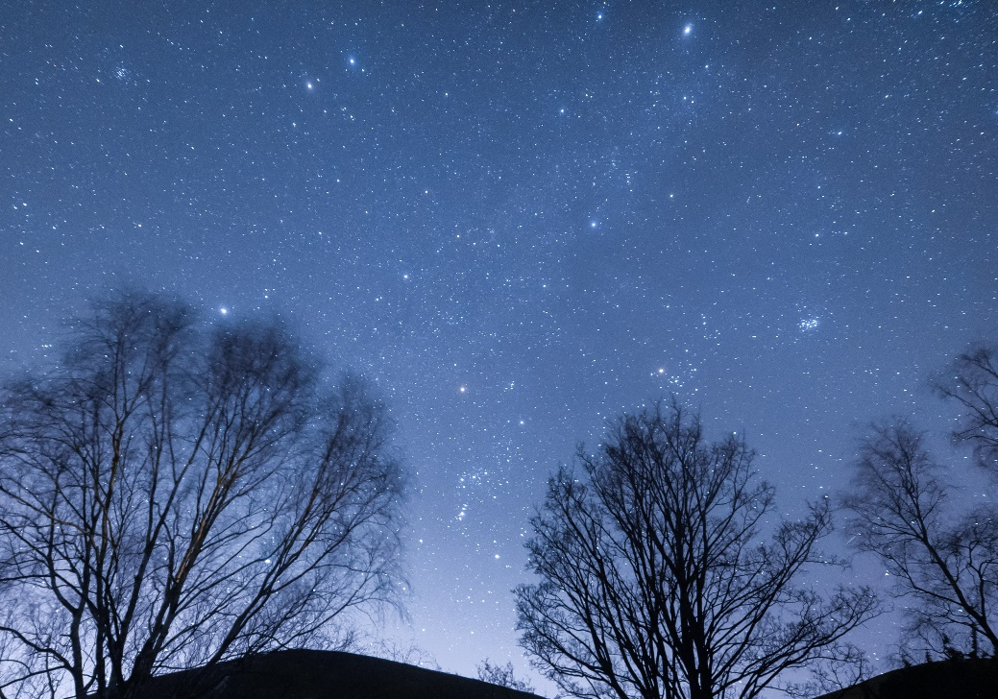
Who Are We to Blame?

As I take a deep breath, I look up at the glistening sky.
All those sparkling stars in the sky like mini sunshine’s.
The heavenly sky, so scenic!

The sky makes me feel so small in such a huge universe
As I turn to look at mum, plucking up the courage to ask
this difficult question desperate to get it out of me!

Does God know the trauma we are going through?
What did we do to hurt God?
What did we do to deserve this?
Does God know that we have been let down?
All these worries are like butterflies in my tummy.
How do we end these horrifying times?
Please God, help us!

Mother can make no promises that everything’s
going to be alright. Mother must see the anxiety on
My face because she lovingly wraps her shawl neatly
Over my shoulders making me feel closer than ever!
I just wish I could bottle this moment and keep
It in my cold and starving heart…

By Grace-Jane McErlean

