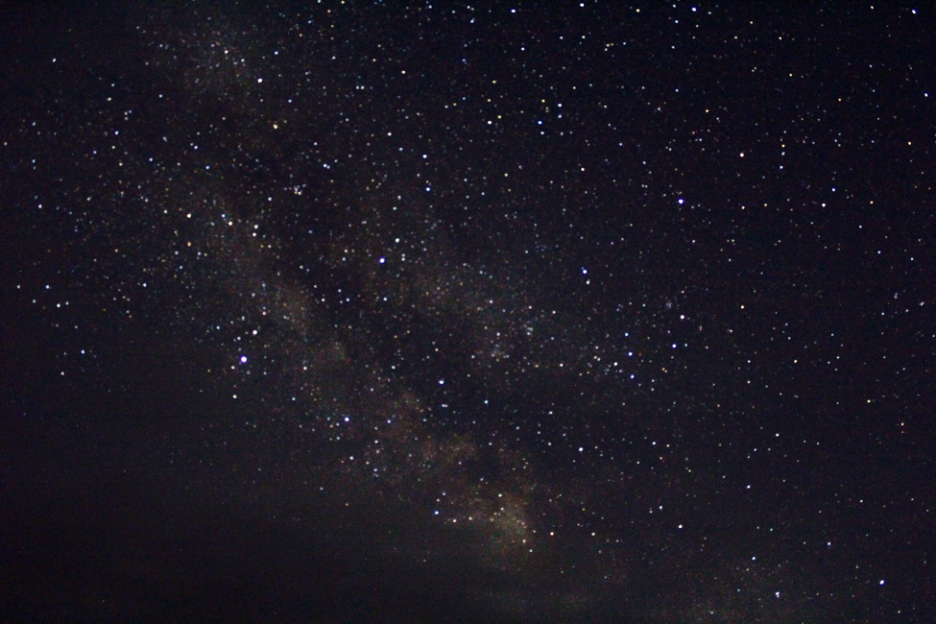
The Hopeless Hungry Night

As I’m preparing myself to ask mother
I hesitate but then I remember the hunger,
The suffering and beautiful dark sky with
Millions of glistening diamonds in it
then I ask mother….

Does God know about us?
Does He know what is happening in Ireland?
Has He forgotten about us?
Has He forsaken us?
Have we offended God?

Then mother answered, “I don’t know
Pet. Sometimes I ask myself the same
Questions.” I ask mother another question,
“Will it end soon?” Mother answered saying,
“I hope, but I can’t guarantee anything.”

Mother came in close and wrapped her
Shawl around me in such a loving and
Comforting way. I hope I can hold on to this moment
Forever!
By Caitlin McGuigan

