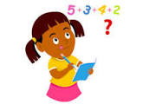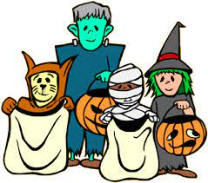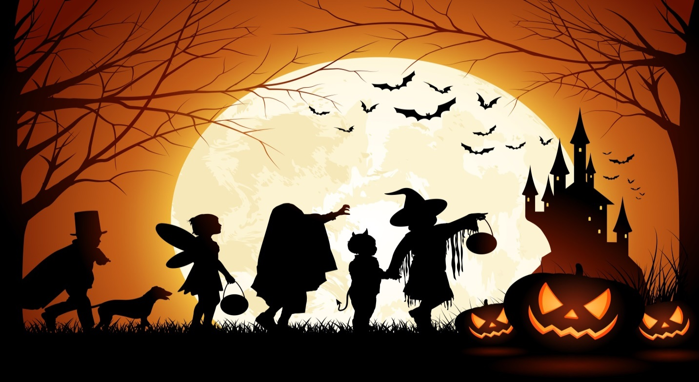

**Sponsored Dance**

**To help raise money for school funds, all classes will participate in a sponsored dance on Friday 21st October.**

**P1 -3 pupils should come to school wearing sports gear, P4 -7 girls should wear PE gear. We are extremely grateful for any donations. Thank you**

**Holidays**

**School will close for the midterm break on Friday 28th October at 12noon and reopen on Monday 7th November.**

**Have a lovely Halloween break**

**Mrs K Owens & staff**

**To celebrate Maths Week Ireland, our Hallowe’en Maths Puzzlers, for pupils and parents, have been sent home today. Get your maths brain working and return your puzzler by Friday for your chance to win a prize.**

**Halloween Hooley**

**We will hold our Halloween Hooley on Friday 28th October.**

**Children should come to school in their costumes.**

**School will finish at 12 noon.**

**Buses available as normal.**